Supplementary material
Alkyne-Linked Spirobifluorene D–π–A–π–D Emitters: Synthesis, Solution-State ICT Photophysics, and Comparative Acceptor Effects
Maria Siddique¹, Mazhar Khan^{1*}, Muhammad Mubashir Khan², Amir Zeeshan³, Rafaqat Khan⁴, Zeeshan Akmal¹, Muhammad Sohail Tahir⁵, and Qifan Yan^{1*}
¹Key Laboratory for Advanced Materials and Feringa Nobel Prize Scientist Joint Research Center, School of Chemistry and Molecular Engineering, East China University of Science & Technology, Shanghai 200237, P. R. China
²Department of Physics, University of Agriculture, Faisalabad, 38000, Pakistan
³School of Science, Harbin Institute of Technology, Campus of University Town of Shenzhen, Shenzhen 518005, P. C. China
⁴Institute of Functional Porous Materials, School of Materials Science and Engineering, Zhejiang Sci-Tech University, Hangzhou 310018, China
⁵University of Science and Technology of China.
*Correspondence: Mazhar Khan (mazharkhan57@yahoo.com); Qifan Yan (yanqifan@ecust.edu.cn)

Supplementary material

The 1H NMR of known compounds is consistent with the reference, and the NMR and mass spectra of unknown compounds.
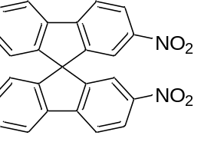
2,2'-Dinitro-9,9'-spirobifluorene: Add 9,9'-spirobifluorene (201.4 mg, 0.633 mmol) to acetic anhydride (4.5 ml), place in an ice-water bath, and stir for 15 min. ¹ Then, concentrated nitric acid was added dropwise under an ice-water bath, and a spot plate was used to monitor until a large amount of dinitration products were produced. Move to room temperature and stir for 3 hours. Then, add deionized water (4.5 ml) under an ice-water bath, and stir overnight. After the reaction is completed, filter, wash with deionized water, dry, and separate on a wet silica gel column. The developing solvent is dichloromethane: petroleum ether = 1:2 (v/v). The product in a mixed solution of dichloromethane and petroleum ether was recrystallized and suction filtered to yield light yellow crystals (115.7 mg, 45%). 1H NMR (400 MHz, CDCl3, ppm): δ 8.34 (dd, J = 8.4, 2.0 Hz, 2H), 8.01 (d, J = 8.5 Hz, 2H), 7.98 (d, J = 7.8 Hz, 2H), 7.55 (d, J = 1.9 Hz, 2H), 7.50 (t, J = 7.6 Hz, 2H), 7.28 (d, J = 7.6 Hz, 2H), 6.78 (d, J = 7.7 Hz, 2H).
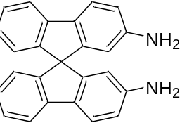
2,2'-Diamino-9,9'-spirobifluorene: Add stannous chloride dihydrate (483.6 mg, 2.1460 mmol) to anhydrous ether (2 ml), stir to obtain a suspension, and add 2,2'-dinitro-9,9'-spirobifluorene (124.5 mg, 0.3066 mmol) to the suspension. ² Then concentrated hydrochloric acid (1.6 ml) was added, heated to reflux at 55 °C overnight, and a white solid precipitated. The solid was filtered, washed with dilute hydrochloric acid (6 M), dissolved in deionized water, and a saturated sodium bicarbonate solution was added until the pH was 8. The mixture was filtered with suction, washed with deionized water, and the filter cake was dried under vacuum to obtain a white solid (62.0 mg, 58%), which was used directly in the next step without purification. 1H NMR (400 MHz, CDCl3, ppm): δ 7.67 (d, J = 7.6 Hz, 2H), 7.60 (d, J = 8.1 Hz, 2H), 7.30 (t, J = 7.5 Hz, 2H), 7.00 (t, J = 7.4 Hz, 2H), 6.70 (d, J = 7.6 Hz, 2H), 6.67 (dd, J = 8.1, 2.1 Hz, 2H), 6.08 (d, J = 1.9 Hz, 2H).
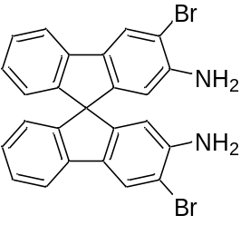
2,2'-Diamino-3,3'-dibromospirobifluorene: Dissolve 2,2'-diamino-9,9'-spirobifluorene (150 mg, 0.4333 mmol) in dichloromethane (25 ml). Add N-bromosuccinimide (NBS) in batches under nitrogen protection, react at room temperature, and monitor with a spot plate.³ After the reaction is completed, filter through a short silica gel column, remove the solvent and obtain a light yellow solid (131.0 mg, 60%). 1H NMR (400 MHz, CDCl3, ppm): δ 7.85 (s, 2H), 7.64 (d, J = 7.6 Hz, 2H), 7.31 (t, J = 7.5 Hz, 2H), 7.03 (t, J = 7.5 Hz, 2H), 6.69 (d, J = 7.6 Hz, 2H), 6.15 (s, 2H).
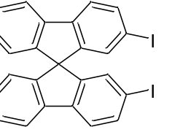
2,2'-Diiodo-9,9'-spirobifluorene (22-2I): Add 2,2'-diamino-9,9'-spirobifluorene (64.2 mg, 0.1855 mmol) to conc. A mixed solution of hydrochloric acid (2.9 ml) and deionized water (2.9 ml) was placed in an ice water bath and stirred for 15 minutes. ⁴ Add sodium nitrite aqueous solution (5%, 0.6 ml) dropwise under the ice water bath, react for 15 minutes, and then ice Add pre-dissolved and cooled potassium iodide (153.8 mg, 0.9275 mmol) aqueous solution dropwise under a water bath, react for 15 min, move to room temperature, and stir for 16 h. After the reaction, extract with dichloromethane, wash with sodium sulfite aqueous solution three times, dry with anhydrous Na2SO4, remove the solvent, and separate on a dry silica gel column using petroleum ether as the developing agent to obtain a light yellow solid (54.8 mg, 52%). 1H NMR (400 MHz, CDCl3, ppm): δ 7.81 (d, J = 7.6 Hz, 2H), 7.71 (dd, J = 8.0, 1.4 Hz, 2H), 7.59 (d, J = 8.0 Hz, 2H), 7.38 (t, J = 7.6 Hz, 2H), 7.15 (t, J = 7.2 Hz, 2H), 7.02 (d, J = 1.3 Hz, 2H), 6.70 (d, J = 7.6 Hz, 2H).
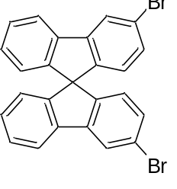
3,3'-Dibromo-9,9'-spirobifluorene (33-2Br): Dissolve 2,2'-diamino-3,3'-dibromospirobifluorene (80.5 mg, 0.1588 mmol) in a mixed solution of deionized water (3.4 ml), concentrated hydrochloric acid (3.4 ml), and tetrahydrofuran (1.4 ml).⁵ Place it in an ice-water bath and stir for 15 min, then add sodium nitrite solution (5%, 0.5 ml) dropwise. , react for 20 minutes, then add hypophosphorous acid solution (50 wt% in H2O, 1.3 ml) dropwise in an ice-water bath, react for 15 minutes, move to room temperature, and stir overnight. After the reaction, extract with dichloromethane, wash with deionized water three times, dry with anhydrous Na2SO4, remove the solvent, and separate on a dry silica gel column using petroleum ether as tkhe eluent to obtain a white solid (41.2 mg, 55%). 1H NMR (400 MHz, CDCl3, ppm): δ 7.96 (d, J = 1.6 Hz, 1H), 7.80 (d, J = 7.6 Hz, 1H), 7.39 (t, J = 8.0 Hz, 1H), 7.23 ( dd, J = 8.1, 1.7 Hz, 1H), 7.15 (t, J = 7.5 Hz, 1H), 6.72 (d, J = 7.6 Hz, 1H), 6.59 (d, J = 8.1 Hz, 1H).
4,7-dibromo-2,1,3-benzothiadiazole (BTD) and 5,8-dibromoquinoxaline acceptor
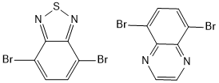
The general method of Buchwald coupling reaction:
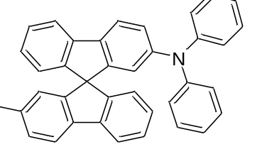
2-Diphenylamine-2'-iodospirobifluorene (22DPAI): Combine 2,2'-diiodo-9,9'-spirobifluorene (444.4 mg, 0.7825 mmol), diphenylamine (88.3 mg, 0.5217 mmol), palladium acetate (11.7 mg, 0.0522 mmol), tri-tert-butylphosphine tetrafluoroborate (60.56 mg, 0.2087 mmol), and potassium tert-butoxide (117.08 mg, 1.0434 mmol) in a pre-dried Schlenk tube under a nitrogen atmosphere. Evacuate and refill the tube with nitrogen three times. Add dry, deoxygenated toluene (15 ml) along the tube wall, seal the reaction vessel, and stir at 50 °C for 1 hour. Subsequently, raise the temperature to 110 °C and stir overnight. After completion, cool the reaction mixture to room temperature, dilute with dichloromethane, and wash three times with saturated sodium chloride solution. Dry the organic layer over anhydrous Na₂SO₄, remove the solvent under reduced pressure, and purify the residue by dry flash column chromatography using petroleum ether: dichloromethane (5:1, v/v) as the eluent. Concentration of the product fraction yields a white solid (190.8 mg, 40%).
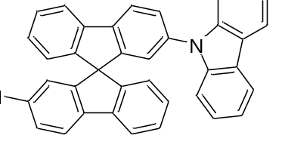
2-Carbazole-2’-iodospirobifluorene (22CBZI): ¹H NMR (400 MHz, CDCl₃, ppm): δ 8.08 – 8.06 (m, 1H), 8.06 – 8.03 (m, 2H), 7.92 (d, J = 7.6 Hz, 1H), 7.77 (d, J = 7.6 Hz, 1H), 7.69 (dd, J = 8.0, 1.5 Hz, 1H), 7.60 (dd, J = 8.1, 1.9 Hz, 1H), 7.54 (d, J = 8.0 Hz, 1H), 7.45 (td, J = 7.6, 0.9 Hz, 1H), 7.39 – 7.34 (m, 1H), 7.32 (t, J = 7.6 Hz, 2H), 7.22 (dd, J = 7.6, 3.7 Hz, 5H), 7.19 – 7.17 (m, 2H), 6.89 (d, J = 1.8 Hz, 1H), 6.85 (d, J = 7.6 Hz, 1H), 6.80 (d, J = 7.6 Hz, 1H). ¹³C NMR (151 MHz, CDCl₃, ppm): δ 150.30, 150.03, 148.19, 147.79, 141.42, 140.95, 140.78, 140.68, 140.57, 137.00, 132.96, 128.55, 128.26, 128.13, 126.67, 125.86, 124.26, 123.87, 123.27, 122.66, 121.84, 121.24, 120.30, 120.21, 119.86, 109.64, 65.78, 53.41, 29.69, 29.04, 22.65, 14.12.
MS (EI): m/z calculated for C₃₇H₂₂IN [M]⁺: 607.08; found: 607.08.
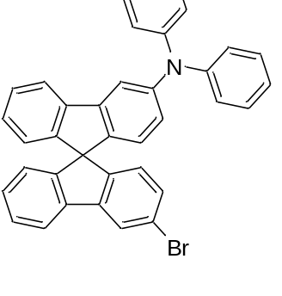
3-Diphenylamine-3’-bromospirobifluorene (33DPAB): ¹H NMR (400 MHz, CDCl₃, ppm): δ 7.95 (d, J = 1.6 Hz, 1H), 7.79 (d, J = 7.3 Hz, 1H), 7.66 (d, J = 7.6 Hz, 1H), 7.54 (d, J = 1.7 Hz, 1H), 7.38 (t, J = 7.5 Hz, 1H), 7.33 – 7.27 (m, 4H), 7.25 (s, 2H), 7.15 (m, 5H), 7.09 (t, J = 7.5 Hz, 1H), 7.03 (t, J = 7.3 Hz, 2H), 6.82 (td, J = 5.5, 2.5 Hz, 2H), 6.70 (s, 1H), 6.68 (s, 1H), 6.57 (d, J = 8.2 Hz, 1H).
¹³C NMR (151 MHz, CDCl₃, ppm): δ 149.31, 149.15, 148.71, 148.62, 147.90, 147.86, 147.79, 147.23, 143.80, 143.43, 142.83, 142.02, 141.91, 141.47, 140.43, 140.33, 133.64, 130.55, 129.26, 128.52, 127.92, 127.86, 127.76, 125.59, 125.17, 124.41, 124.25, 124.20, 124.03, 123.88, 123.21, 122.79, 121.67, 120.22, 120.14, 115.51, 65.11.
MS (EI): m/z calculated for C₃₇H₂₄BrN [M]⁺: 561.11; found: 561.11.

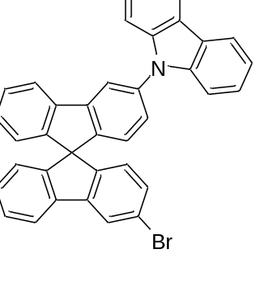
3-Carbazole-3’-bromospirobifluorene (33CBZB): White solid (43%).¹H NMR (400 MHz, CDCl₃, ppm): δ 8.17 (d, J = 7.7 Hz, 2H), 8.01 (s, 2H), 7.85 (d, J = 7.6 Hz, 1H), 7.82 (d, J = 7.7 Hz, 1H), 7.51 (d, J = 8.2 Hz, 2H), 7.43 (t, J = 7.5 Hz, 4H), 7.31 (t, J = 7.2 Hz, 4H), 7.24 – 7.17 (m, 2H), 6.93 (d, J = 8.0 Hz, 1H), 6.88 (d, J = 7.6 Hz, 1H), 6.79 (d, J = 7.6 Hz, 1H), 6.75 (d, J = 8.1 Hz, 1H).
¹³C NMR (151 MHz, CDCl₃, ppm): δ 148.57, 148.52, 147.18, 147.06, 143.94, 143.51, 140.93, 140.48, 137.63, 130.74, 128.71, 128.61, 128.16, 126.63, 125.94, 125.64, 125.18, 124.26, 124.19, 123.40, 122.01, 120.40, 120.34, 119.97, 118.68, 109.87, 65.47.
MS (EI): m/z calculated for C₃₇H₂₂BrN [M]⁺: 559.09; found: 559.10.
General method for connecting TMS-acetylene via 2’-substituted Sonogashira coupling reaction:
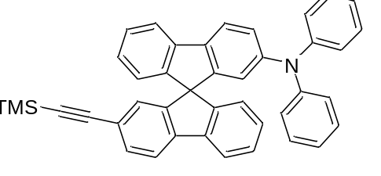
2-diphenylamine-2'-TMS acetylenic spirobifluorene (22DPAT): 2-Diphenylamine-2'-iodo-9,9'-spirobifluorene (20.1 mg, 0.03292 mmol), Pd(PPh₃)₂Cl₂ (0.7 mg, 0.0009876 mmol), and CuI (0.06 mg, 0.0003292 mmol) were added to a pre-dried Schlenk tube under a nitrogen atmosphere. The tube was evacuated and refilled with nitrogen three times. Dry, deoxygenated tetrahydrofuran (2 ml) and diisopropylamine (1 ml) were added sequentially. The mixture was stirred to dissolve the solids, then trimethylsilylacetylene (TMS-acetylene, 16.2 mg, 0.1646 mmol) was added. The reaction vessel was sealed and stirred at room temperature overnight.
Upon completion, the reaction mixture was diluted with petroleum ether and concentrated under reduced pressure. The residue was dissolved in dichloromethane and washed three times with an aqueous NH₄Cl solution. The organic layer was dried over anhydrous Na₂SO₄, concentrated, and purified by dry flash column chromatography using petroleum ether: dichloromethane (5:1, v/v) as the eluent to afford a white solid (17.2 mg, 90%).
¹H NMR (400 MHz, CDCl₃, ppm): δ 7.74 (d, J = 3.6 Hz, 1H), 7.72 (d, J = 3.6 Hz, 1H), 7.69 (s, 1H), 7.67 (d, J = 1.2 Hz, 1H), 7.45 (dd, J = 7.9, 1.4 Hz, 1H), 7.33 (tdd, J = 7.6, 3.5, 1.0 Hz, 2H), 7.15 (t, J = 1.9 Hz, 1H), 7.13 – 7.12 (m, 3H), 7.11 (s, 1H), 7.07 – 7.03 (m, 1H), 7.01 (dd, J = 8.3, 2.1 Hz, 1H), 6.97 (d, J = 1.1 Hz, 2H), 6.95 (s, 2H), 6.94 – 6.88 (m, 4H), 6.80 (d, J = 7.6 Hz, 1H), 6.65 (d, J = 7.5 Hz, 1H), 6.52 (d, J = 2.0 Hz, 1H), 0.20 (s, 9H).
¹³C NMR (151 MHz, CDCl₃, ppm): δ 149.44, 149.10, 148.63, 148.12, 147.64, 147.49, 142.05, 141.49, 140.86, 136.52, 131.82, 129.04, 128.16, 127.81, 127.74, 127.41, 126.99, 123.93, 123.90, 123.82, 122.63, 121.95, 120.61, 120.34, 119.83, 119.64, 119.40, 105.52, 94.11, 65.65, -0.06.
MS (EI): m/z calculated for C₄₂H₃₃NSi [M]⁺: 579.24; found: 579.24.
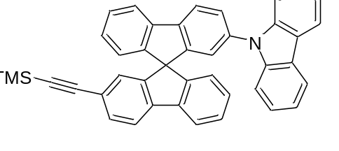
2-Carbazole-2’-TMS acetylenic spirobifluorene (22CBZT): ¹H NMR (400 MHz, CDCl₃, ppm): δ 8.11 (s, 1H), 8.08 (d, J = 8.4 Hz, 2H), 7.96 (d, J = 7.6 Hz, 1H), 7.82 (d, J = 7.5 Hz, 1H), 7.77 (d, J = 7.9 Hz, 1H), 7.63 (dd, J = 8.1, 2.0 Hz, 1H), 7.55 (dd, J = 7.9, 1.4 Hz, 1H), 7.48 (td, J = 7.5, 1.0 Hz, 1H), 7.43 – 7.39 (m, 1H), 7.35 (d, J = 8.0 Hz, 2H), 7.31 – 7.26 (m, 3H), 7.25 – 7.19 (m, 3H), 7.05 – 7.03 (m, 1H), 6.97 (d, J = 1.8 Hz, 1H), 6.91 (d, J = 7.6 Hz, 1H), 6.84 (d, J = 7.5 Hz, 1H), 0.24 (s, 9H).
¹³C NMR (151 MHz, CDCl₃, ppm): δ 150.24, 148.56, 148.43, 148.08, 142.09, 140.98, 140.95, 140.78, 140.53, 137.10, 132.18, 128.42, 128.18, 128.11, 128.09, 127.36, 126.49, 125.83, 124.27, 123.92, 123.26, 122.60, 121.13, 120.48, 120.21, 120.17, 119.97, 119.84, 109.69, 105.37, 94.40, 65.78, -0.08.
MS (EI): m/z calculated for C₄₂H₃₁NSi [M]⁺: 577.22; found: 577.22.

A general method for connecting TMS-acetylene via 3’-substituted Sonogashira coupling reaction:
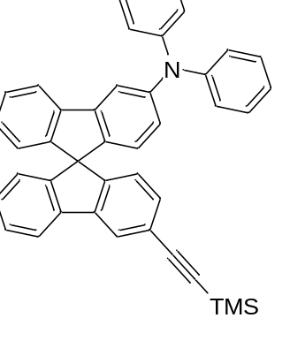
3-diphenylamine-3’-TMS acetylenic spirobifluorene (33DPAT): 3-Diphenylamine-3'-bromo-9,9'-spirobifluorene (279.9 mg, 0.4976 mmol), Pd(PPh₃)₂Cl₂ (10.48 mg, 0.014928 mmol), and CuI (0.95 mg, 0.004976 mmol) were added to a pre-dried Schlenk flask under a nitrogen atmosphere. The flask was evacuated and refilled with nitrogen three times. Dry, deoxygenated diisopropylamine (5 ml) was added, and the mixture was stirred. Trimethylsilylacetylene (TMS-acetylene, 244.38 mg, 2.4880 mmol) was then added under a continuous nitrogen flow. The reaction vessel was sealed and stirred at 80 °C overnight. Upon completion, the reaction mixture was diluted with petroleum ether and concentrated under reduced pressure. The residue was dissolved in dichloromethane and washed three times with an aqueous NH₄Cl solution. The organic layer was dried over anhydrous Na₂SO₄, concentrated, and purified by dry flash column chromatography using petroleum ether:dichloromethane (5:1, v/v) as the eluent, yielding a white solid (265.4 mg, 92%).
¹H NMR (400 MHz, CDCl₃, ppm): δ 7.85 (s, 1H), 7.73 (d, J = 7.6 Hz, 1H), 7.57 (d, J = 7.6 Hz, 1H), 7.46 (d, J = 1.9 Hz, 1H), 7.29 (t, J = 7.3 Hz, 1H), 7.18 (t, J = 3.6 Hz, 6H), 7.07 (d, J = 7.9 Hz, 5H), 7.00 (t, J = 7.5 Hz, 1H), 6.95 (t, J = 7.3 Hz, 2H), 6.76 – 6.73 (m, 1H), 6.72 (d, J = 4.4 Hz, 1H), 6.67 (d, J = 7.8 Hz, 1H), 6.59 (d, J = 7.5 Hz, 1H), 6.47 (d, J = 8.2 Hz, 1H), 0.20 (s, 9H).
¹³C NMR (151 MHz, CDCl₃, ppm): δ 149.42, 148.96, 148.86, 147.88, 147.83, 142.83, 142.20, 141.76, 141.49, 140.83, 131.59, 129.25, 128.20, 127.89, 127.81, 127.70, 124.47, 124.24, 124.10, 124.03, 123.97, 123.95, 123.46, 122.76, 122.42, 120.15, 120.10, 115.48, 105.34, 94.05, 65.49, 0.01.
MS (EI): m/z calculated for C₄₂H₃₃NSi [M]⁺: 579.24; found: 579.24.
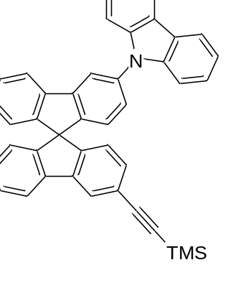
3-Carbazole-3’-TMS acetylenic spirobifluorene (33CBZT): White solid (90%). ¹H NMR (400 MHz, CDCl₃, ppm): δ 8.17 (d, J = 7.7 Hz, 2H), 8.01 (d, J = 8.9 Hz, 2H), 7.87 (d, J = 7.6 Hz, 1H), 7.82 (d, J = 7.6 Hz, 1H), 7.51 (d, J = 8.2 kHz, 2H), 7.45 (d, J = 7.9 Hz, 2H), 7.43 – 7.37 (m, 2H), 7.31 (t, J = 7.1 Hz, 4H), 7.22 (d, J = 7.5 Hz, 1H), 7.18 (t, J = 6.5 Hz, 1H), 6.92 (d, J = 8.0 Hz, 1H), 6.87 (d, J = 7.6 Hz, 1H), 6.82 (d, J = 7.8 Hz, 1H), 6.78 (d, J = 7.6 Hz, 1H), 0.29 (s, 9H). ¹³C NMR (151 MHz, CDCl₃, ppm): δ 148.78, 148.75, 148.38, 147.32, 143.52, 141.91, 140.98, 140.93, 137.56, 131.74, 128.57, 128.38, 128.11, 128.09, 126.59, 125.93, 125.22, 124.24, 124.16, 124.02, 123.63, 123.39, 122.78, 120.33, 119.95, 118.63, 109.89, 105.20, 94.32, 65.78, 53.41, 22.65, 0.01. MS (EI) m/z calculated for C₄₂H₃₁NSi: 577.22 [M]⁺; found 577.22
General methods for removing TMS protecting groups:
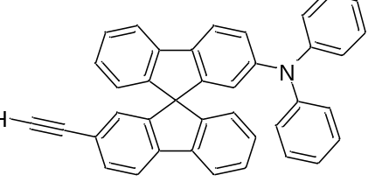
2-Diphenylamine-2'-acetylenic spirobifluorene (22DPAH): Add 2-diphenylamine-2'-TMS acetylenic spirobifluorene (48.0 mg, 0.0828 mmol) into a pre-dried Schlenk bottle under nitrogen, and add Stir and dissolve CH2Cl2 (2 ml), then add MeOH (2 ml), stir and mix evenly, then add anhydrous K2CO3 (57.2 mg, 0.4141 mmol) under nitrogen, seal the reaction bottle, and stir at room temperature for 12 h. After the reaction is completed, the reaction system is quenched with NH4Cl solution, extracted with dichloromethane, dried with anhydrous Na2SO4, spin-dried, and separated on a dry silica gel column. The developing solvent is petroleum ether: dichloromethane = 5:1 (v/v) , a white solid (24.4 mg, 58%) was obtained.
¹H NMR (400 MHz, CDCl₃, ppm): δ 7.74 (d, J = 7.6 Hz, 2H), 7.69 (t, J = 8.8 Hz, 2H), 7.47 (dd, J = 7.9, 1.4 Hz, 1H), 7.34 (t, J = 7.5 Hz, 2H), 7.15 – 7.09 (m, 5H), 7.07 – 6.99 (m, 2H), 6.96 (s, 2H), 6.94 (s, 3H), 6.91 (t, J = 7.4 Hz, 2H), 6.82 (d, J = 7.6 Hz, 1H), 6.65 (d, J = 7.6 Hz, 1H), 6.53 (d, J = 1.7 Hz, 1H), 3.00 (s, 1H). ¹³C NMR (151 MHz, CDCl₃, ppm): δ 149.36, 149.05, 148.84, 148.05, 147.65, 147.50, 142.32, 141.48, 140.79, 136.57, 131.85, 129.04, 128.27, 127.84, 127.79, 127.63, 127.02, 123.97, 123.95, 123.87, 123.84, 122.61, 120.90, 120.65, 120.39, 119.93, 119.69, 119.43, 84.03, 77.11, 65.64, 53.41, 26.90. MS (EI) m/z calculated for C₃₉H₂₅N: 507.20 [M]⁺; found 507.20
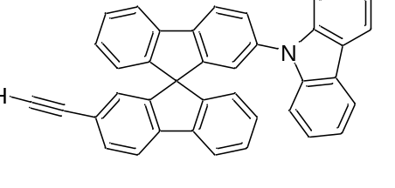
2-Carbazole-2’-acetylenic spirobifluorene (22CBZH): ¹H NMR (400 MHz, CDCl₃, ppm): δ 8.07 (d, J = 1.3 Hz, 1H), 8.06 – 8.03 (m, 2H), 7.92 (d, J = 7.6 Hz, 1H), 7.79 (d, J = 7.6 Hz, 1H), 7.75 (d, J = 8.0 Hz, 1H), 7.59 (dd, J = 8.1, 1.9 Hz, 1H), 7.51 (dd, J = 7.9, 1.3 Hz, 1H), 7.47 – 7.42 (m, 1H), 7.40 – 7.35 (m, 1H), 7.31 (t, J = 7.2 Hz, 2H), 7.24 – 7.16 (m, 6H), 7.01 – 6.98 (m, 1H), 6.90 (d, J = 1.8 Hz, 1H), 6.88 (d, J = 7.6 Hz, 1H), 6.79 (d, J = 7.6 Hz, 1H), 3.01 (s, 1H). ¹³C NMR (151 MHz, CDCl₃, ppm): δ 150.17, 148.50, 148.36, 148.28, 142.39, 140.97, 140.89, 140.83, 140.57, 137.10, 132.17, 128.53, 128.21, 128.16, 128.13, 127.61, 126.59, 125.83, 124.22, 123.99, 123.25, 122.62, 121.16, 120.54, 120.25, 120.18, 120.07, 119.83, 109.66, 83.89, 77.36, 65.77, 53.41. MS (EI) m/z calculated for C₃₉H₂₃N: 505.18 [M]⁺; found 505.18
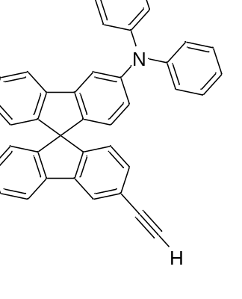
3-Diphenylamine-3’-ethynespirobifluorene (33DPAH):
¹H NMR (400 MHz, CDCl₃, ppm): δ 7.96 (s, 1H), 7.82 (d, J = 7.6 Hz, 1H), 7.66 (d, J = 7.6 Hz, 1H), 7.55 (d, J = 1.9 Hz, 1H), 7.38 (t, J = 7.5 Hz, 1H), 7.33 – 7.27 (m, 5H), 7.25 (s, 1H), 7.16 (t, J = 6.3 Hz, 5H), 7.09 (t, J = 7.5 Hz, 1H), 7.03 (t, J = 7.3 Hz, 2H), 6.83 (dd, J = 7.5, 3.2 Hz, 2H), 6.77 (d, J = 7.8 Hz, 1H), 6.69 (d, J = 7.5 Hz, 1H), 6.57 (d, J = 8.2 Hz, 1H), 3.11 (s, 1H). ¹³C NMR (151 MHz, CDCl₃, ppm): δ 149.77, 148.95, 148.78, 147.87, 142.85, 142.10, 141.85, 141.49, 140.70, 131.71, 129.26, 128.31, 127.91, 127.84, 127.74, 124.47, 124.25, 124.15, 124.06, 123.94, 123.63, 122.77, 121.40, 120.17, 120.13, 115.51, 83.91, 65.49, 53.41. MS (EI) m/z calculated for C₃₉H₂₅N: 507.20 [M]⁺; found 507.20
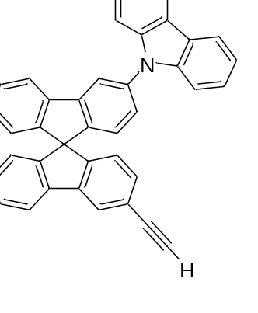
3-Carbazole-3’-acetylenic spirobifluorene (33CBZH): ¹H NMR (400 MHz, CDCl₃, ppm): δ 8.17 (d, J = 7.7 Hz, 2H), 8.02 (s, 2H), 7.88 (d, J = 7.6 Hz, 1H), 7.82 (d, J = 7.6 Hz, 1H), 7.51 (d, J = 8.1 Hz, 2H), 7.46 – 7.39 (m, 4H), 7.32 (td, J = 6.9, 3.2 Hz, 4H), 7.20 (dt, J = 14.9, 7.5 Hz, 2H), 6.94 (d, J = 8.0 Hz, 1H), 6.89 (d, J = 7.6 Hz, 1H), 6.84 (d, J = 7.8 Hz, 1H), 6.79 (d, J = 7.6 Hz, 1H), 3.14 (s, 1H). ¹³C NMR (151 MHz, CDCl₃, ppm): δ 149.11, 148.69, 148.36, 147.22, 143.53, 142.01, 140.93, 140.85, 137.60, 131.87, 128.60, 128.49, 128.14, 126.61, 125.94, 125.23, 124.24, 124.21, 124.12, 123.80, 123.39, 121.75, 120.38, 120.33, 119.96, 118.66, 109.89, 83.79, 65.78, 53.41, 31.58, 22.64, 14.11. MS (EI) m/z calculated for C₃₉H₂₃N: 505.18 [M]⁺; found
General method of connecting donor and acceptor via Sonogashira coupling reaction:
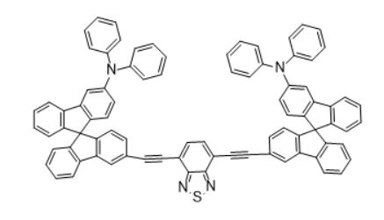
Synthesis 33BTD-DPA: 3-Diphenylamine-3'-ethynyl-9,9'-spirobifluorene (33DPAH) (24.4 mg, 0.04830 mmol), 4,7-dibromo-2,1,3-benzothiadiazole (BTD) (7.3 mg, 0.02415 mmol), Pd(PPh₃)₂Cl₂ (0.41 mg, 0.0005796 mmol), and CuI (0.04 mg, 0.0001932 mmol) were combined in a pre-dried Schlenk flask under a nitrogen atmosphere. The flask was evacuated and refilled with nitrogen three times. Dry, deoxygenated tetrahydrofuran (1 ml) and diisopropylamine (1 ml) were added sequentially. The reaction vessel was sealed and stirred at room temperature for 48 hours.
Upon completion, the mixture was diluted with petroleum ether and concentrated under reduced pressure. The residue was dissolved in dichloromethane and washed three times with aqueous NH₄Cl. The organic layer was dried over anhydrous Na₂SO₄, concentrated, and purified by dry flash column chromatography using a gradient eluent of petroleum ether: dichloromethane (from 5:1 to 2:1, v/v) to afford a yellow solid (27.4 mg, 80%).
¹H NMR (400 MHz, CDCl₃, ppm): δ 7.73 (s, 1H), 7.63 (dd, J = 17.4, 7.9 Hz, 5H), 7.33 – 7.25 (m, 5H), 7.17 (t, J = 7.7 Hz, 11H), 7.00 – 6.91 (m, 16H), 6.74 (d, J = 7.6 Hz, 3H), 6.64 (s, 2H).
¹³C NMR (101 MHz, CDCl₃, ppm): δ 153.11 – 152.85, 150.08 – 149.81, 149.08 – 148.60, 147.87 – 147.51, 147.73 – 147.10, 141.47 – 141.15, 137.06 – 136.74, 132.96 – 132.00, 130.21 – 128.07, 124.53 – 122.91, 114.03 – 113.83.
MS (MALDI-TOF-MS): M/z calculated for C₈₄H₅₀N₄S [M]⁺: 1146.38; found: 1162.6 [M+16]⁺
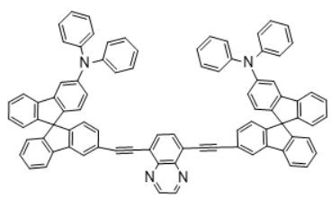
33QXN-DPA: 3-Diphenylamine-3'-ethynyl-9,9'-spirobifluorene (24.4 mg, 0.04830 mmol), 5,8-dibromoquinoxaline (6.9 mg, 0.02415 mmol), Pd(PPh₃)₂Cl₂ (0.41 mg, 0.0005796 mmol), and CuI (0.04 mg, 0.0001932 mmol) were combined in a pre-dried Schlenk flask under a nitrogen atmosphere. The flask was evacuated and refilled with nitrogen three times. Dry, deoxygenated tetrahydrofuran (1 ml) and diisopropylamine (1 ml) were added sequentially. The reaction vessel was sealed and stirred at room temperature for 48 hours.
Upon completion, the mixture was diluted with petroleum ether and concentrated under reduced pressure. The residue was dissolved in dichloromethane and washed three times with aqueous NH₄Cl. The organic layer was dried over anhydrous Na₂SO₄, concentrated, and purified by dry flash column chromatography using a gradient eluent of petroleum ether: dichloromethane (from 5:1 to 2:1, v/v) to afford a yellow solid (27.4 mg, 80%).
¹H NMR (400 MHz, CDCl₃, ppm): δ 7.66 (d, J = 7.6 Hz, 1H), 7.61 (d, J = 8.2 Hz, 1H), 7.29 (td, J = 7.5, 1.1 Hz, 2H), 7.21 – 7.12 (m, 4H), 7.06 (td, J = 7.5, 1.1 Hz, 1H), 6.98 (d, J = 1.4 Hz, 2H), 6.98 – 6.89 (m, 5H), 6.74 (d, J = 7.6 Hz, 1H), 6.65 (d, J = 2.1 Hz, 1H
¹³C NMR (101 MHz, CDCl₃, ppm): δ 153.11 – 152.85, 150.08 – 149.81, 149.08 – 148.60, 147.87 – 147.51, 147.73 – 147.10, 141.47 – 141.15, 137.06 – 136.74, 132.96 – 132.00, 130.21 – 128.08, 124.53 – 122.91, 114.03 – 113.83. MS (MALDI-TOF-MS): m/z calculated for C₈₄H₅₀N₄ [M]⁺: 1140.41; found: 1146.

Table S1. Optimization of reaction conditions of spirodifluorene diiodide.
Solvent | Temperature | Catalyst | Time | Operation | Yield
HCl, CH₃CN, H₂O | 0 °C, 90 °C | None | 2 h | Add saturated KI solution drop by drop | 0 %
HCl, CH₃CN, H₂O | 0 °C, 90 °C | None | 2 h | Quickly pour in pre-cooled saturated KI solution | 0 %
HCl, CH₃CN, H₂O | 0 °C, 90 °C | None | 2 h | Transfer the mixed reaction solution to the saturated KI solution | 0 %
HCl, H₂O | 0 °C, R.T. (room temp) | None | 16 h | Add saturated KI solution drop-wise | 52 %
HCl, H₂O | 0 °C, R.T. | CuI | 16 h | Add saturated KI solution drop by drop | 51 %

Table S2.Buchwald C-N Bond formation reaction product yield.
3,3’dibromospirobifluoren | Diphenylamine | Adding order | Yield
1.0 equiv | 1.0 equiv | Add amine in one go | 30%
1.0 equiv | 1.0 equiv | Add amine gradually | 0%
1.5 equiv | 1.0 equiv | Add amine in one go | 40%
2 equiv | 1.0 equiv | Add amine in one go | 44%

Table S3. Exploring the conditions of Stille Coupling.
Acceptor | Catalyst | Ligand | Solvent | Temperature | Time | Yield
Bromine acceptor | Pd(PPh₃)₂Cl₂ | — | Toluene | 110 °C | 12 h | 0 %
Iodine acceptor | Pd(PPh₃)₂Cl₂ | — | Toluene | 110 °C | 12 h | 0 %
Iodine acceptor | Pd₂(dba)₃ | P(o-Tol)₃ | Toluene | 110 °C | 12 h | 0 %
Table S4. Optimization of substitution conditions for 3,3′-trimethylsilicylene.
Catalyst | Solvent | Temperature (°C) | Time (h) | Yield (%)
Pd(PPh₃)₂Cl₂; CuI | i-Pr₂NH; THF | 60 | 12 | 0
Pd(PPh₃)₂Cl₂; CuI | i-Pr₂NH; THF | 80 | 12 | 0
Pd(PPh₃)₂Cl₂; CuI | i-Pr₂NH | 60 | 12 | 60
Pd(PPh₃)₂Cl₂; CuI | i-Pr₂NH | 80 | 12 | 90
Pd(PPh₃)₂Cl₂; CuI | TEA | 80 | 12 | 70

Table S5. Photophysical properties of QXN and BTD in toluene
Compound | λ_{abs}ª(nm) | λ_{em}^{a,b}(nm) | Φ^{c}(%) | ^{d}Eg^{opt}(eV)
QXN | 310 | 450 | 14.3 | 2.44
BTD | 352 | 400 | 16.4 | 2.43

The photophysical properties of QXN-DPA and BTD-DPA were evaluated in toluene solution and are summarized in Table 1.5. QXN-DPA exhibited absorption at 310 nm and fluorescence emission centered around 450 nm, whereas BTD-DPA showed absorption near 352 nm with emission around 400 nm. Both compounds displayed pronounced Stokes shifts, consistent with excited-state relaxation involving intramolecular charge-transfer character. Fluorescence quantum yields of 14.3% for QXN-DPA and 16.4% for BTD-DPA were obtained under identical experimental conditions. The optical bandgaps estimated from the absorption onsets were approximately 2.43–2.44 eV for both compounds. These results demonstrate that the acceptor unit significantly influences the absorption energy, emission wavelength, and fluorescence behavior of the spirobifluorene-based D–π–A–π–D framework.

NMR spectrum of new compounds

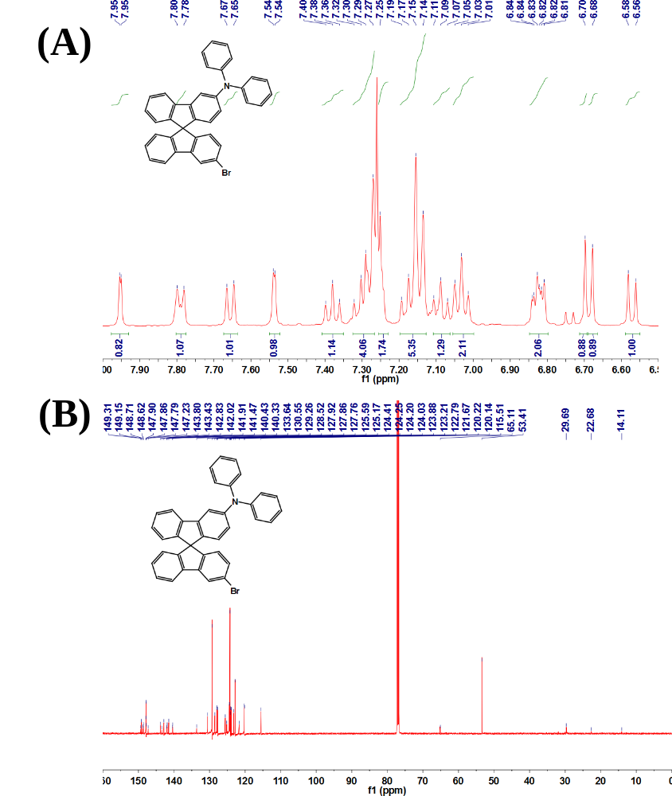

Figure S1. (a) ¹H NMR (400 MHz, CDCl₃) and (b) ¹³C NMR (151 MHz, CDCl₃) spectra of 3-diphenylamine-3′-bromospirobifluorene (33DPAB)

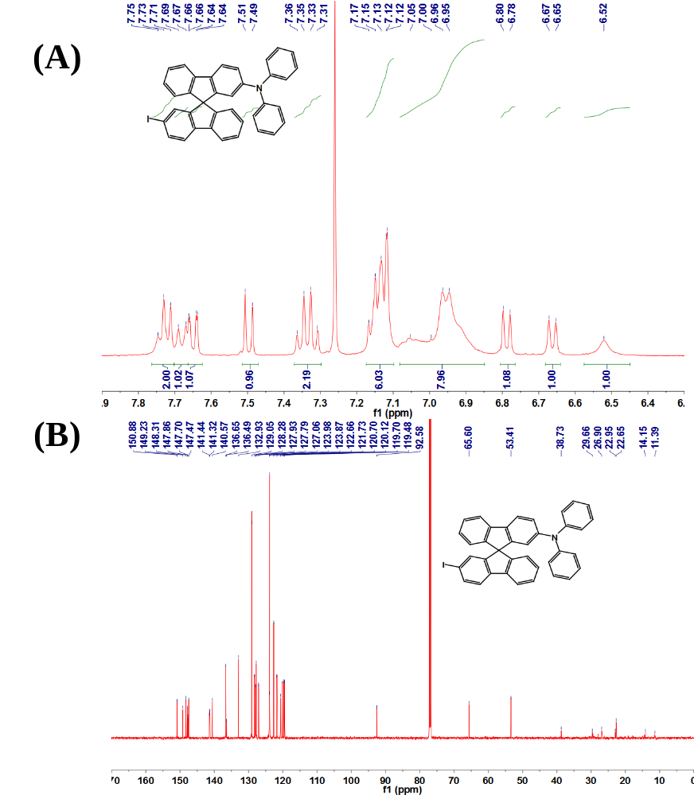

Figure S2. (a) ¹H NMR (400 MHz, CDCl₃) and (b) ¹³C NMR (151 MHz, CDCl₃) spectra of 2-diphenylamine-2′-iodospirobifluorene (22DPAI).

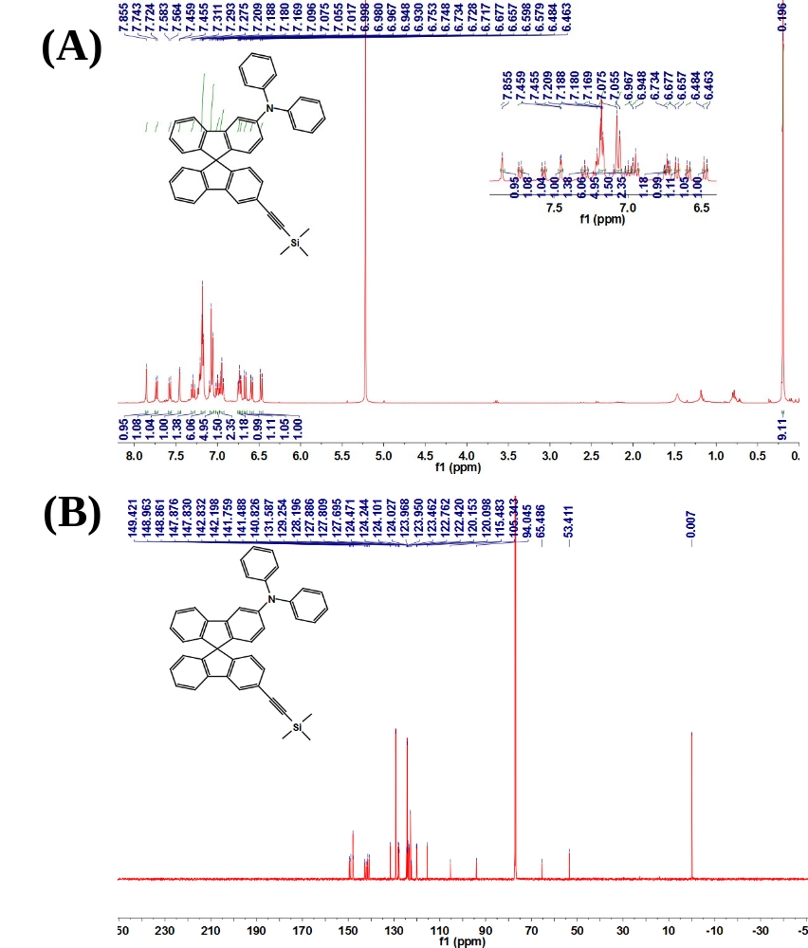
Figure S3. (a) ¹H NMR (400 MHz, CDCl₃) and (b) ¹³C NMR (151 MHz, CDCl₃) spectra of 2-diphenylamine-2′-TMS-acetylenic spirobifluorene (22DPAT).

Figure S4. (a) ¹H NMR (400 MHz, CDCl₃) and (b) ¹³C NMR (151 MHz, CDCl₃) spectra of 2-diphenylamine-2′-acetylenic spirobifluorene (22DPAH)
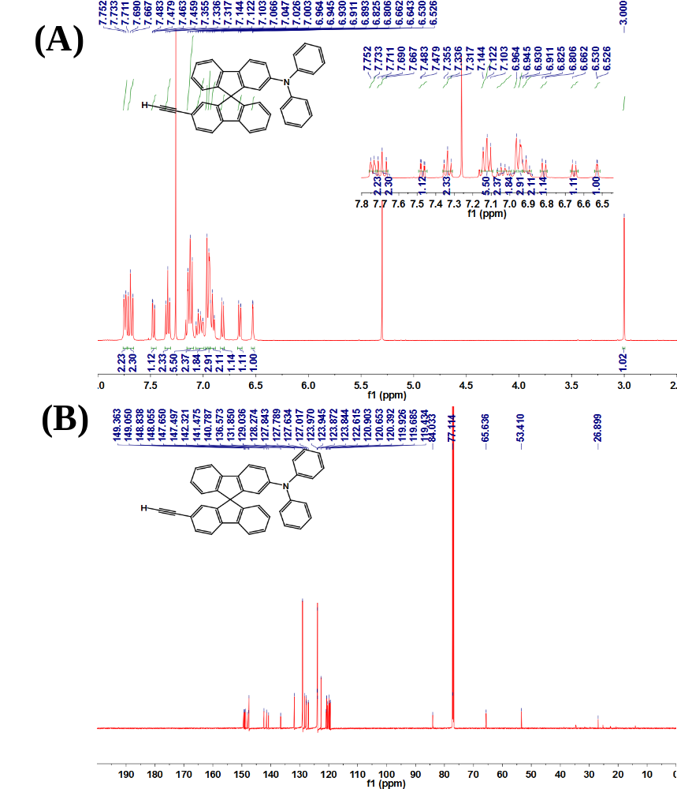

Figure S5. ¹HNMR spectra of compound 33BTD-DPA.
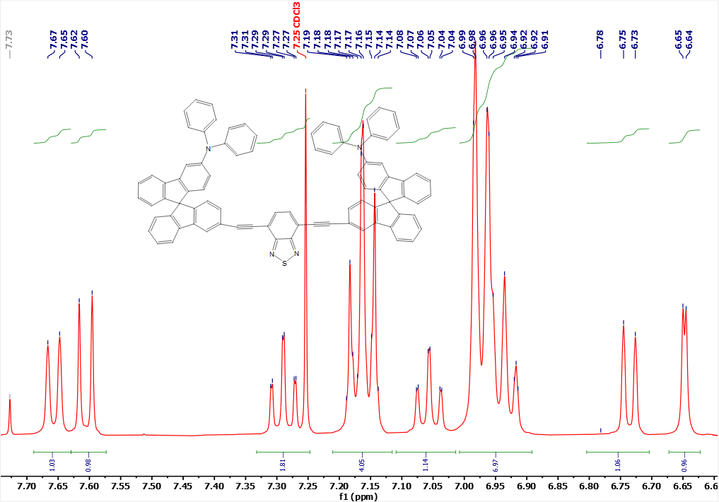
¹H NMR (400 MHz, in CDCl3)

Figure S6. ¹H spectra of compound 33QXN-DPA.
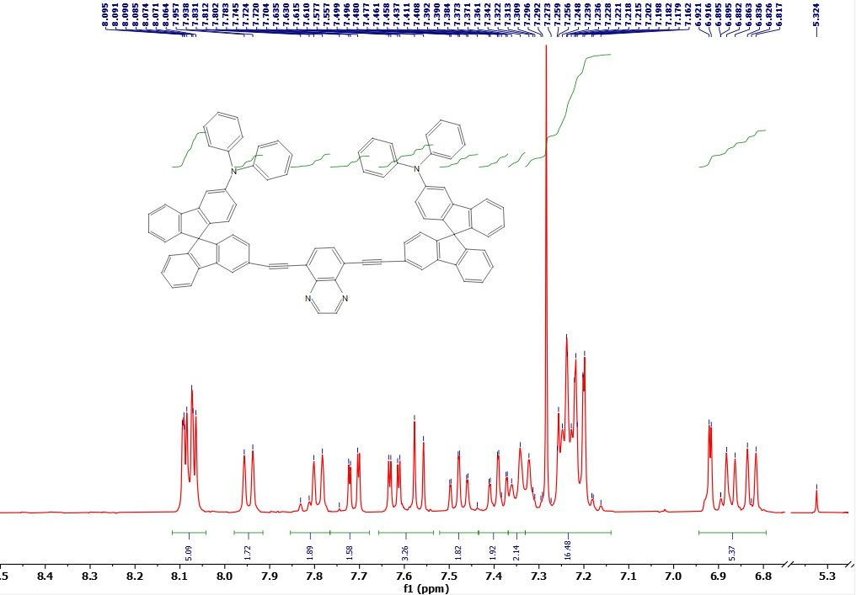
¹H NMR (400 MHz, in CDCl3)

Water GCT Premier
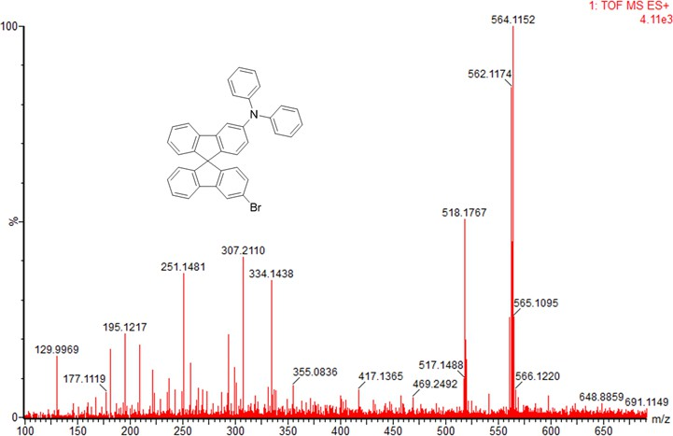
Water GST Premier
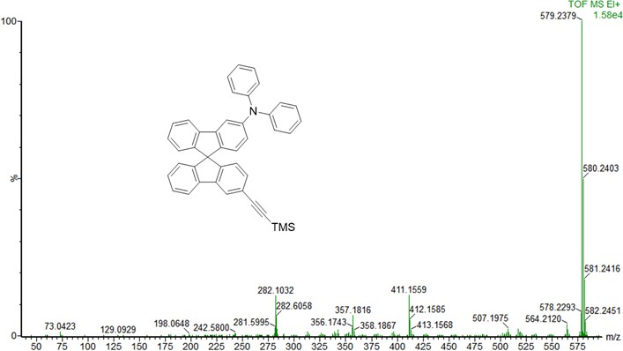
Water GST Premeir
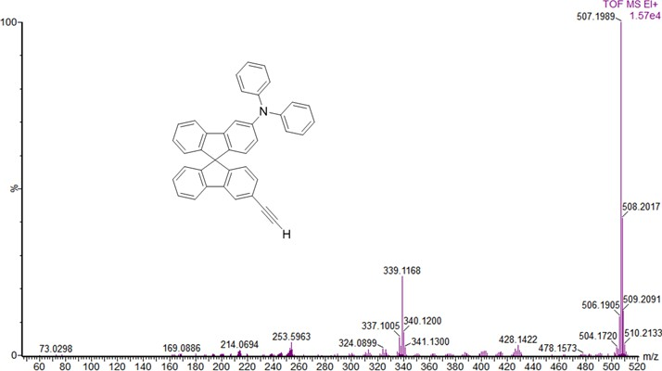
Water GST Premeir

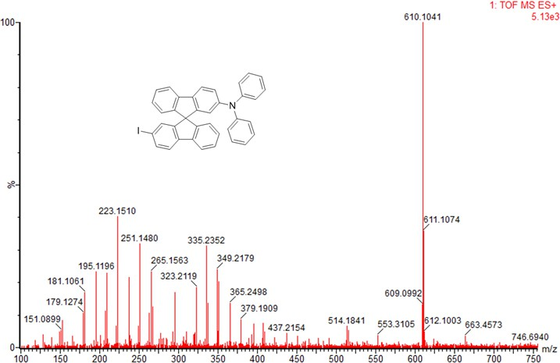
Water GST Premier
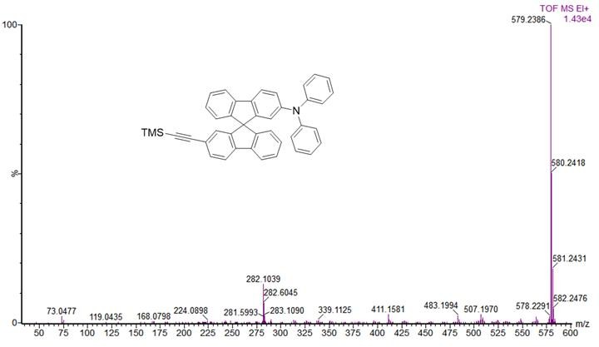
Water GST Premier
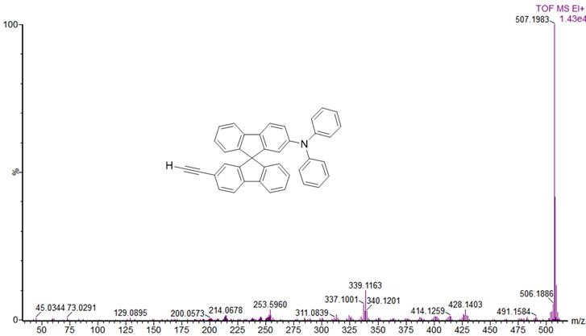
Water GST Premier
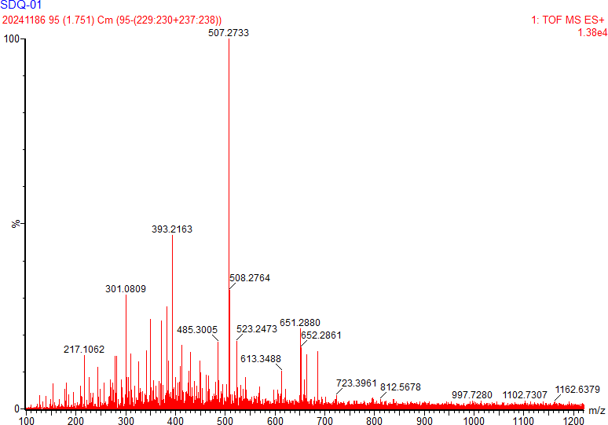
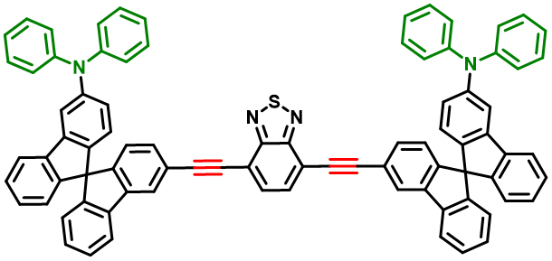

Water GST Premier
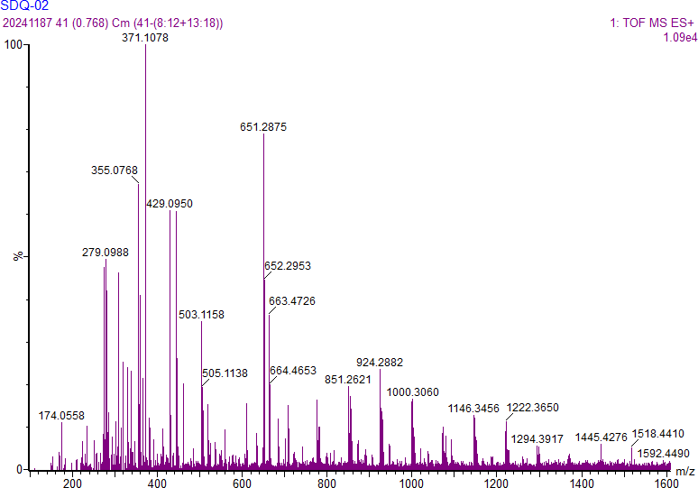
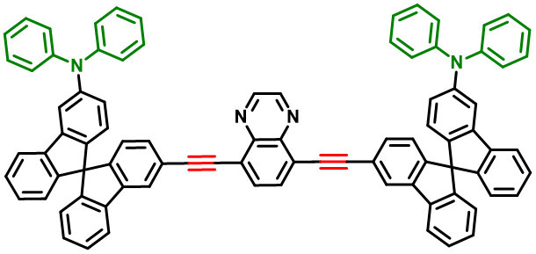

Water GST Premier

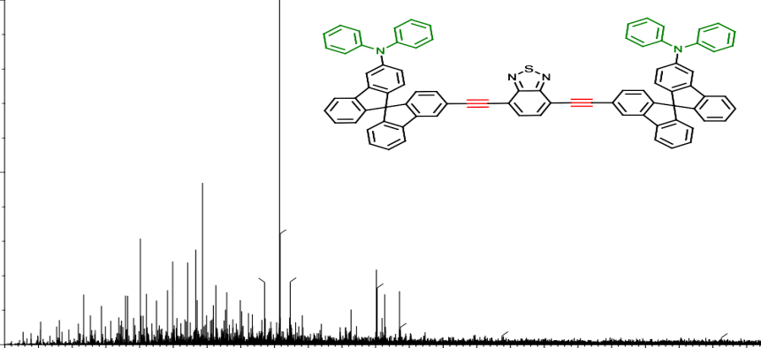
393.2163
508.2764
301.0809
349.1872
485.3005
523.2473
651.2880
652.2861
217.1062
613.3488
181.0972
686.4537
797.2125 837.5262
997.7280
1102.7307
1162.6379

Water GST Premier

References

Thiemann, F., et al., Synthesis of enantiomerically pure dissymmetric 2,2′-disubstituted 9,9′-spirobifluorenes. European Journal of Organic Chemistry, 2005. 2005(10): p. 1991-2001.

Wong, K.T., et al., A novel right-angled ligand that forms polymeric metal-organic frameworks with nanometer-sized square cavities. Crystal Growth & Design, 2005. 5(2): p. 667-671.

Ma, X., et al., Novel spirobifluorene- and dibromospirobifluorene-based polyimides of intrinsic microporosity for gas separation applications. Macromolecules, 2013. 46(24): p. 9618-9624.

Xu, S., et al., Copper-promoted reductive coupling of aryl iodides with 1,1,1-trifluoro-2-iodoethane. Organic Letters, 2014. 16(9): p. 2306-2309.

He, Z., et al., Synthesis of multi-substituted 9,9′-spirobifluorenes and their applications in organic light-emitting diodes. Chinese Chemical Letters, 2026. 3

