Supplementary File
Littering as Environmental Incivility: Socio-Economic Interactions in Urban Communities in Nigeria
Martin Okokon Ufi^{1,2}
¹Sustainable Development Centre, University of Abuja, Abuja, Nigeria
²Centre for the Study of the Economies of Africa (CSEA), Abuja, Nigeria
*Correspondence Author : martinufi@gmail.com

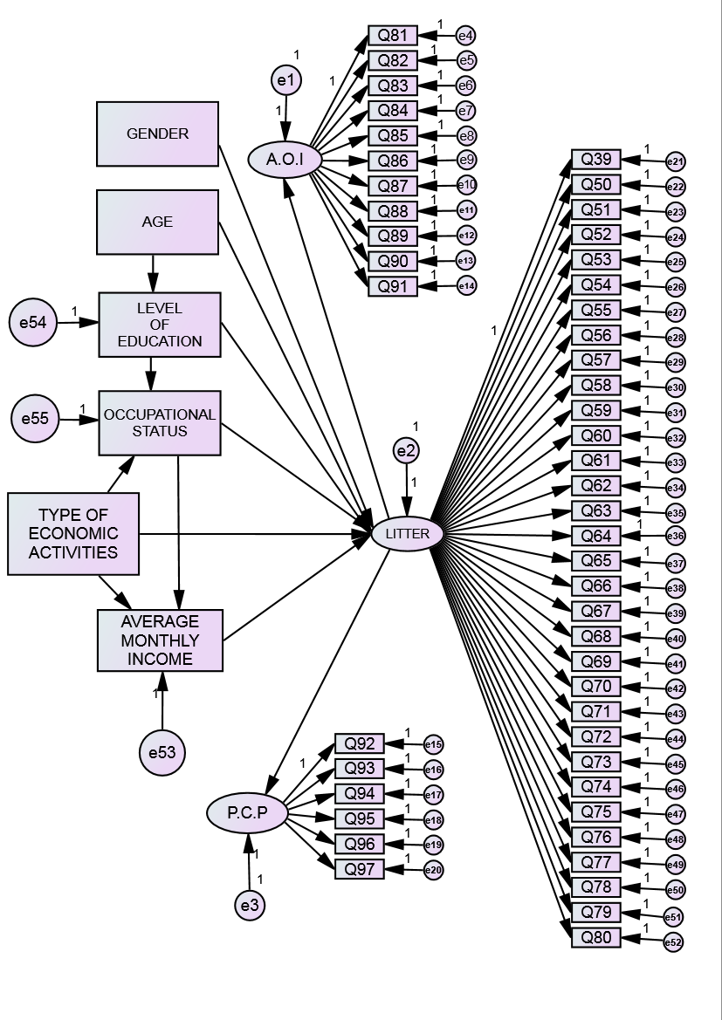

Figure S1. Proposed Model for Estimation

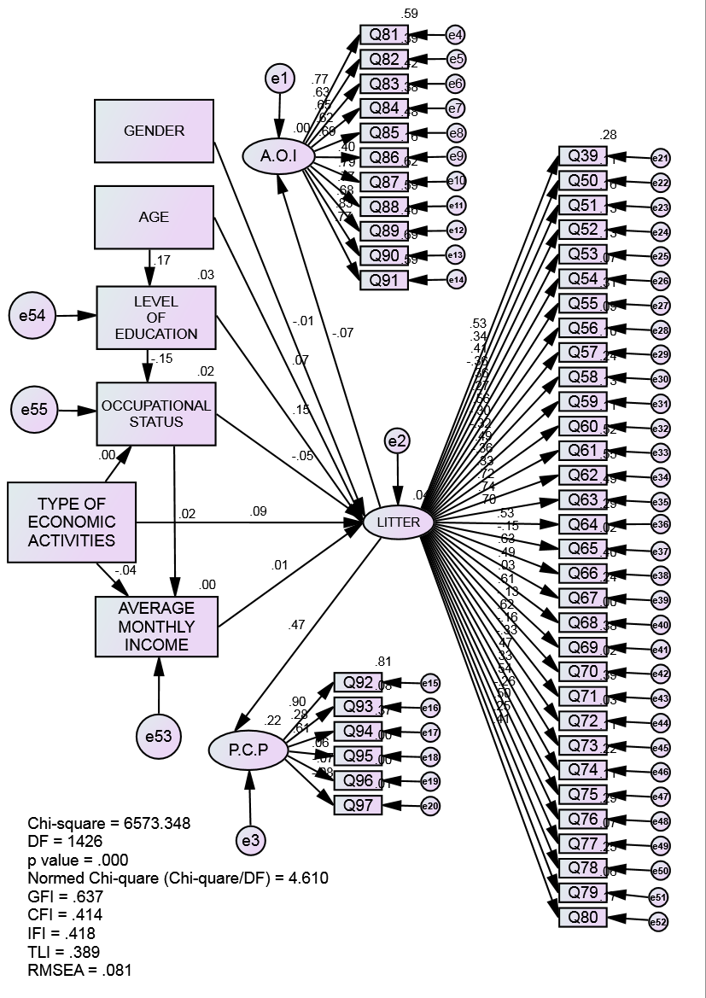

Figure S2. Initial Estimated Model.

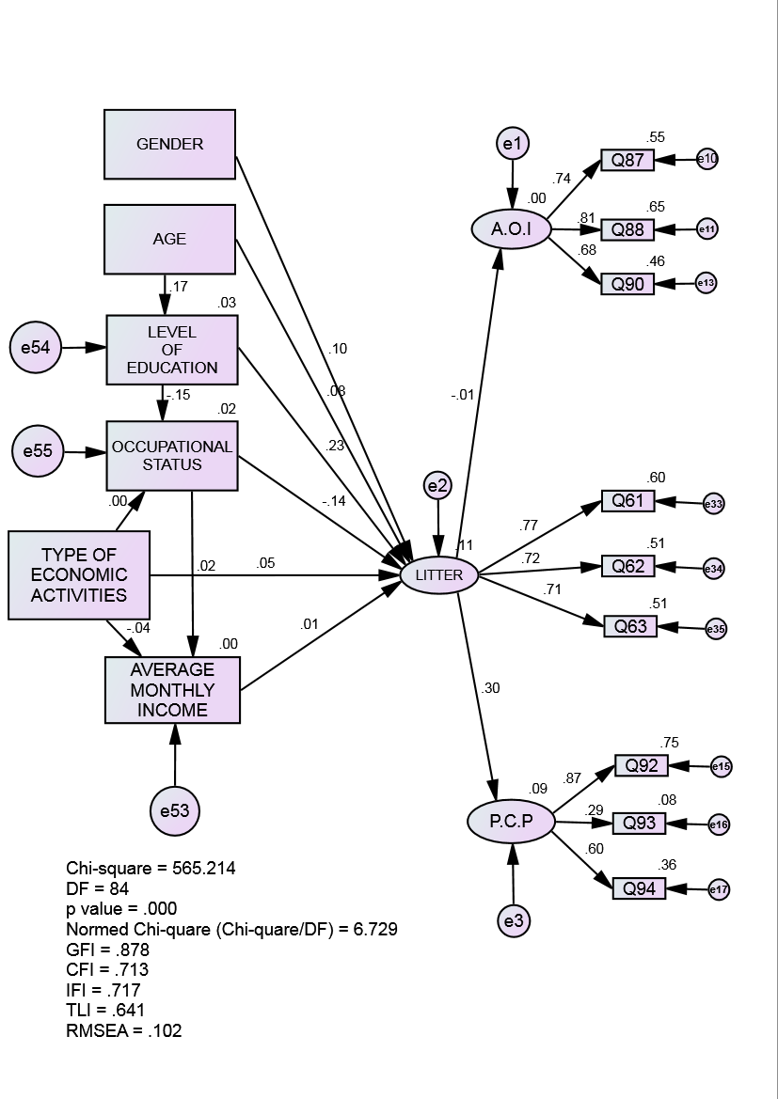

Figure S3. Modified Model.

