Supplementary File
Role of Soil Fertility in Influencing Nutritional Quality of Indigenous Browse Species in Mixed Crop–Livestock Systems
Abiola Bruce-Smith^{1*}, Samantha Providence - Forrester¹, Kimberly Coppin¹, Ewart Smith^{2*}, Neveen Gray³, Chetwynd Osborne⁴
¹Department of Agriculture, University of Guyana Faculty of Agriculture and Forestry, Turkeyen Greater Georgetown, Guyana.
²Department of Forestry, University of Guyana Faculty of Agriculture and Forestry, Turkeyen Greater Georgetown, Guyana.
³Department of Fisheries, Ministry of Agriculture, Guyana.
⁴Department of Environmental Studies, University of Guyana Faculty of Earth and Environmental Sciences, Turkeyen Greater Georgetown, Guyana.
*Corresponding author: abiola.bruce-smith@uog.edu.gy ( ABS), Ewart Smith (ES) Ewart.smith@uog.edu.gy

Table S1. Mean comparison of proximate and mineral parameters by species. Different letters indicate statistically significant differences (p < .05) using TukeyHSD test between species.

Species | Protein  (mean ± SE, mg kg⁻¹) | Moisture  (mean ± SE, mg kg⁻¹) | Fat  (mean ± SE, mg kg⁻¹) | Fibre  (mean ± SE, mg kg⁻¹) | Ash  (mean ± SE, mg kg⁻¹) | Calcium  (mean ± SE,  mg kg⁻¹) | Potassium  (mean ± SE,  mg kg⁻¹) | Sodium  (mean ± SE,  mg kg⁻¹) | Zinc  (mean ± SE,  mg kg⁻¹)
Carica papaya | 186,433ª ± 260 | 76,366ª ± 88 | 46,433ª ± 33 | 68,466ª ± 33 | 108,400ª ± 0 | 9,800ª ± 2,713 | 83,166ª ± 62,416 | 2,733ª ± 33 | 196,666ª ± 33
Colocasia esculenta | 243,100^{b} ± 346 | 83,533^{b} ± 33 | 47,000^{b} ± 57 | 85,366^{b} ± 88 | 113,500^{b} ± 100 | 10,633ª ± 33 | 31,333ª ± 33 | 2,366ª ± 33 | 270,633^{b} ± 2,633
Crotalaria spectabilis | 248,633^{c} ± 145 | 88,700^{c} ± 288 | 30,233^{c} ± 145 | 99,666^{c} ± 260 | 95,900^{c} ± 200 | 10,466ª ± 3,233 | 26,266ª ± 33 | 633^{b} ± 33 | 291,700^{c} ± 850
Desmodium intortum | 242,433^{b} ± 33 | 109,600^{d} ± 0 | 49,933^{d} ± 88 | 152,833^{d} ± 145 | 84,133^{d} ± 566 | 15,366ª ± 1,530 | 4,800ª ± 115 | 1,033^{c} ± 33 | 570,800^{d} ± 100
Gliricidia sepium | 272,166^{d} ± 375 | 82,700e ± 57 | 53,300e ± 0 | 104,800e ± 231 | 91,266e ± 66 | 9,433ª ± 2,624 | 6,200ª ± 57 | 2,400ª ± 57 | 403,600e ± 0
Ipomoea batatas | 273,933^{d} ± 606 | 85,166^{f} ± 145 | 48,366^{f} ± 202 | 121,300^{f} ± 577 | 59,666^{f} ± 166 | 13,800ª ± 346 | 8,933ª ± 33 | 600^{b} ± 0 | 192,033ª ± 33
Lysiloma latisiliquum | 212,933e ± 202 | 74,000^{g} ± 115 | 47,700^{g} ± 0 | 184,066^{g} ± 433 | 84,966^{d} ± 433 | 11,233ª ± 3,086 | 10,333ª ± 33 | 1,900ª ± 600 | 498,133^{f} ± 33
Manihot esculenta | 281,200^{f} ± 231 | 77,400^{h} ± 115 | 51,500^{h} ± 115 | 56,366^{h} ± 88 | 90,433e ± 166 | 14,200ª ± 2,713 | 20,833ª ± 33 | 1,633^{c} ± 33 | 376,700^{g} ± 3,350
Pueraria montana | 249,800^{c} ± 866 | 88,300^{c} ± 288 | 43,400^{i} ± 115 | 202,733^{i} ± 33 | 95,866^{c} ± 133 | 14,000ª ± 288 | 17,700ª ± 57 | 2,266ª ± 88 | 165,633^{h} ± 145
Senna alata | 199,933^{g} ± 433 | 87,566^{i} ± 33 | 59,566^{j} ± 33 | 153,766^{d} ± 744 | 75,133^{g} ± 66 | 14,266ª ± 1,398 | 3,266ª ± 88 | 2,800ª ± 57 | 420,100^{i} ± 0
Samanea saman | 266,500^{h} ± 346 | 76,000ª ± 57 | 55,766^{k} ± 145 | 167,500^{j} ± 346 | 109,733^{h} ± 366 | 8,166ª ± 3,333 | 14,666ª ± 33 | 566^{b} ± 33 | 907,366^{j} ± 33

Table S2. Food and Agriculture Organization of the United Nations (FAO) soil unit classification for Guyana.
Sample ID | Latitude | Longitude | Likely Soil Unit (FAO Map) | Soil Unit Description
SSKCL-PPKCLP | 5.99873 | -58.331139 | Near Georgetown: 1c/1d/2c | White Sand Regosols / Red-Yellow Podzolic soils / Sandy Red-Yellow Latosols
SSKCLP-PPKCLM | 6.000693 | -58.336023 | Near Georgetown: 1c/1d/2c | White Sand Regosols / Red-Yellow Podzolic soils / Sandy Red-Yellow Latosols
SSKCL-PPKCLRB | 6.00813 | -58.302219 | Near Georgetown: 1c/1d/2c | White Sand Regosols / Red-Yellow Podzolic soils / Sandy Red-Yellow Latosols
SSKCL-PPKCLSA | 6.018553 | -58.302416 | Near Georgetown: 1c/1d/2c | White Sand Regosols / Red-Yellow Podzolic soils / Sandy Red-Yellow Latosols
SSKCL-PPKCLQS | 6.016807 | -58.303278 | Near Georgetown: 1c/1d/2c | White Sand Regosols / Red-Yellow Podzolic soils / Sandy Red-Yellow Latosols
SSKCL-PPKCLSP,C | 6.02454 | -58.271711 | Near Georgetown: 1c/1d/2c | White Sand Regosols / Red-Yellow Podzolic soils / Sandy Red-Yellow Latosols

This table presents the GPS coordinates for plant and soil sample collection sites in Guyana. Each row lists a unique sample identification code alongside its latitude and longitude values—data obtained during field surveys. The coordinates indicate the precise geographic locations where samples were collected, supporting traceability and enabling spatial analysis of soil and plant properties relative to environmental and land-use factors. By linking each sample to its mapped position, the table facilitates further study of local soil characteristics, assists with data validation, and provides essential reference points for future research and field visits.

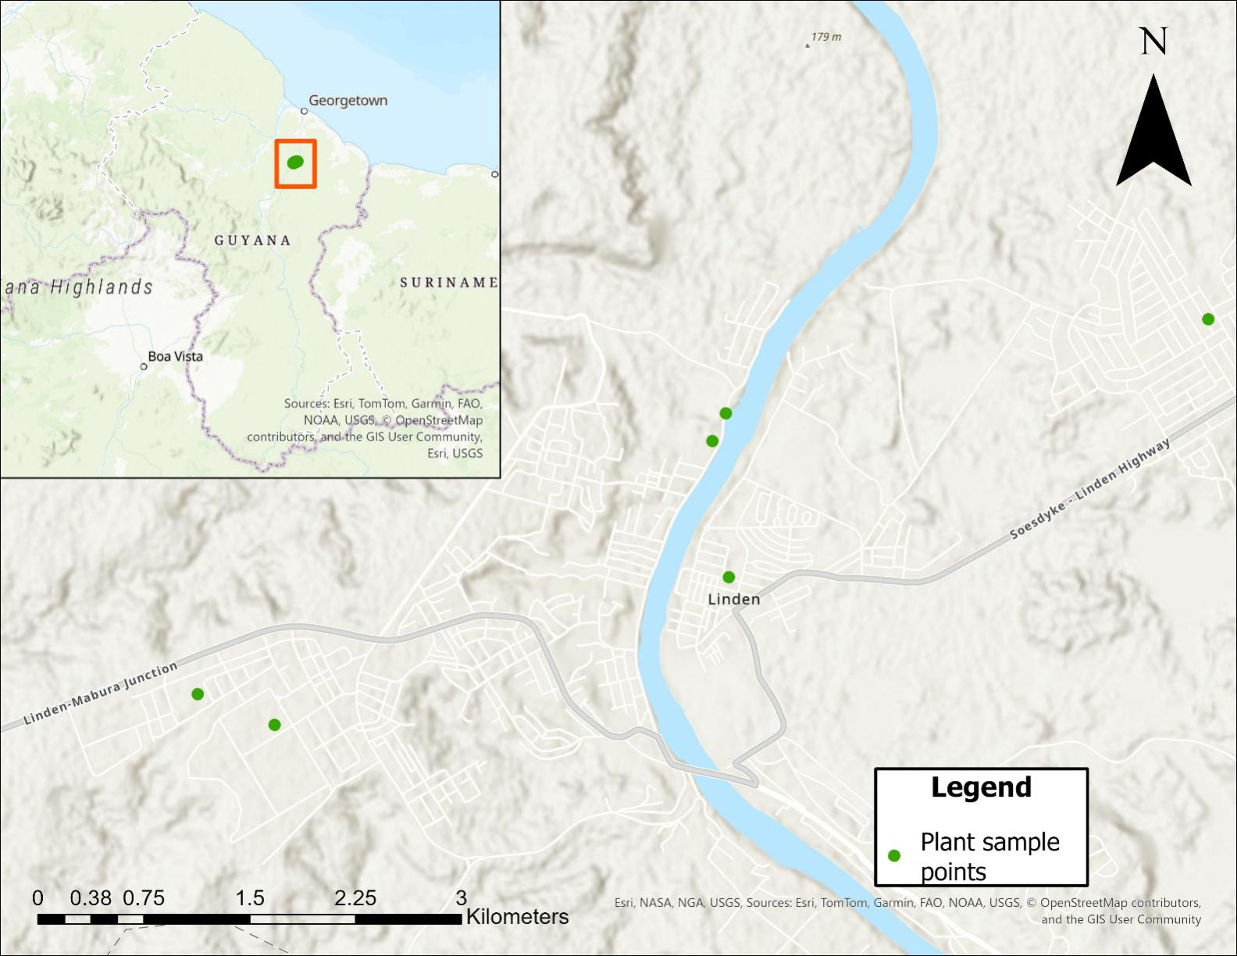
Figure S1. Plant sampling locations in the Linden area, Guyana.
The figure is a location map showing plant sampling points in and around Linden, Guyana. The main map displays the Linden area along the Demerara River with major roads, including the Soesdyke–Linden Highway and the Linden–Mabura Junction road, over a shaded‑relief background. Green dots mark individual plant sample points distributed on both banks of the river and within Linden’s road network, as indicated in the legend. An inset map in the upper left shows the position of the Linden study area within Guyana, highlighted by an orange box and a central green point.

Table S3. Soil chemical properties of seven client samples from Guyana.
Client ID | pH | pH | OM | Olsen P | K | Ca | Mg | Na | S | Zn | Mn | B | Cu | Fe | CEC
Client ID | pH | pH | % | ppm | ppm | ppm | ppm | ppm | ppm | ppm | ppm | ppm | ppm | ppm | meq/100g
SSKCL1QS | 5.91 | 7.17 | 2.3 | 2 | 15.04 | 363.92 | 17 | 9 | 9 | 6.74 | 2.8 | 0.04 | 1.14 | 15.9 | 3.4
SSKCL2P | 6 | 7 | 3.2 | 48 | 17 | 544 | 19 | 14 | 8 | 2.5 | 7.5 | 0.1 | 0.2 | 13.8 | 5
SSKL3SA | 5.2 | 7.2 | 3.8 | 3 | 22 | 169 | 28 | 18 | 8 | 2.9 | 1.7 | 0 | 1.4 | 52.2 | 2.5
SSKCL4M | 5.8 | 7.4 | 0.7 | 1 | 6 | 100 | 13 | 4 | 2 | 0.2 | 1.2 | 0 | 0 | 1.3 | 0.9
SSKCL5RB | 6.1 | 7.2 | 5 | 3 | 17 | 638 | 13 | 7 | 11 | 2.8 | 2.5 | 0.1 | 1.8 | 20.3 | 4.7
SSKCL6RT | 5.4 | 7.3 | 16.3 | 1 | 16 | 48 | 14 | 10 | 467 | 0.1 | 1.2 | 0.2 | 0.1 | 8.3 | 1.1
SSKCL7CSP | 4.9 | 7.3 | 2.5 | 1 | 23 | 65 | 28 | 8 | 14 | 0.2 | 0.7 | 0.1 | 0 | 35.2 | 1.3

The soil analysis results show a considerable range in soil pH values, extending from strongly acidic (4.9) to slightly neutral (7.3). Organic matter (OM) content varies greatly across the samples, with some soils exhibiting very low levels (0.7%) and others reaching extremely high percentages (16.3%). Available phosphorus (Olsen P) is generally low, though one sample stands out with an exceptionally high reading. Major nutrients such as potassium, calcium, magnesium, sodium, and sulfur also display wide variability, highlighting significant differences in soil fertility among the samples. Micronutrients—including zinc, manganese, boron, copper, and iron—are present in variable amounts.
Cation Exchange Capacity (CEC) ranges from poor (0.9 meq/100g) to moderate (5 meq/100g); lower CEC values are typical of sandy and sandy loam soils, which are common in Guyana. Altogether, these results reflect the country’s diverse soil types: mainly sandy loams and sandy soils, but also some loamy sands and organic pegasse or peaty soils. In Guyana, sandy and sandy loam soils are particularly prevalent in the uplands, coastal regions, river valleys, and savannas. These soils are characterized by low to moderate fertility, acidic pH, and limited nutrient retention. Pegasse soils, which have very high organic matter content, are typically found in low-lying swampy areas and are distinguished by their peaty, organic nature.

